Noise-Aware Variational Quantum and Hybrid Quantum-Classical Models for Parkinson’s Disease Detection in Small Biomedical Datasets

Geetha J
Dept. of Computer Science and Engineering
M S Ramaiah Institute of Technology
Bangalore, India
geethaj@msrit.edu
Shrinidhi Pawar
Dept. of Computer Science and Engineering
M S Ramaiah Institute of Technology
Bangalore, India
1MS22CS141@msrit.edu
Ishika Mohol
Dept. of Computer Science and Engineering
M S Ramaiah Institute of Technology
Bangalore, India
1MS22CS069@msrit.edu
Hoor Parvaiz
Dept. of Computer Science and Engineering
M S Ramaiah Institute of Technology
Bangalore, India
1MS22CS063@msrit.edu
Rifah Balquees
Dept. of Computer Science and Engineering
M S Ramaiah Institute of Technology
Bangalore, India
1MS22CS114@msrit.edu

Abstract—Parkinson's disease (PD) is a progressive neurodegenerative disorder where early diagnosis is clinically significant for treatment planning and long-term care. Speech-based biomarkers have enabled machine learning-driven non-invasive screening pipelines. While classical models have demonstrated strong results on structured biomedical data, Quantum Machine Learning (QML) methods are increasingly investigated for potentially richer feature representations and alternative optimization behavior. However, many QML studies rely on idealized conditions that do not reflect realistic noisy intermediate-scale quantum (NISQ) constraints. This paper presents a noise-aware comparative framework for PD detection across classical baselines, pure Variational Quantum Classifiers (VQC), and hybrid quantum-classical architectures, evaluating noiseless and noisy VQC settings using depolarizing-noise simulation. Results show classical models remain strongest overall, while hybrid architectures outperform pure quantum variants on practical screening metrics. This work provides a reproducible benchmark identifying current QML limitations and realistic hybrid integration pathways for future clinical AI systems.
Keywords: Parkinson’s disease detection, quantum machine learning, VQC, hybrid quantum-classical model, noise-aware benchmarking, biomedical speech analysis
- INTRODUCTION
Parkinson's disease is characterized by progressive motor and non-motor impairment and benefits from earlier diagnostic intervention. Voice and speech features are widely used in computational PD detection due to their accessibility and non-invasive acquisition [1], [2]. Classical machine learning approaches such as SVM, Logistic Regression, and Random Forest remain standard baselines due to established performance and practical reliability [11], [12]. Recent progress in QML, especially variational approaches, has motivated exploration of quantum-enhanced clinical classifiers [3], [4]. VQC-based methods are attractive in NISQ settings because they are trainable with parameterized circuits and compatible with hybrid optimization [5], [6]. However, practical clinical adoption requires evidence under realistic noisy conditions rather than ideal simulator assumptions [5].
Therefore, this work addresses the following question: how do noise-aware VQC and hybrid quantum-classical methods compare against classical models for Parkinson's disease detection under small-data biomedical constraints? The goal is not to claim immediate quantum superiority, but to provide an honest and reproducible benchmark of performance, stability, and generalization under realistic conditions.
II. RELATED WORK
Parkinson’s disease detection using biomedical voice signals has been widely studied using classical machine learning techniques because speech features such as jitter, shimmer, and harmonicity provide useful information for classification [1], [2]. Early telemonitoring studies showed that dysphonia-based measures can effectively support non-invasive screening and progression tracking for Parkinson’s disease [1], [2]. In most practical settings, classical models such as Logistic Regression, Support Vector Machines, and Random Forest remain strong baselines because they are computationally efficient, stable on small datasets, and easier to interpret than more complex alternatives [11], [12]. However, their performance can still be limited when data are small, noisy, or highly non-linear, which motivates exploration of alternative learning paradigms.
Quantum machine learning has emerged as a promising direction for classification problems because quantum feature maps can embed data into high-dimensional Hilbert spaces and potentially capture complex relationships more efficiently [3], [4]. Variational Quantum Classifiers are especially attractive in the NISQ era because they combine trainable quantum circuits with classical optimization [5], [6]. Prior work has shown that quantum-enhanced feature spaces and variational models can provide a different representational capacity from classical methods [3], [4]. At the same time, the literature also makes it clear that these models are sensitive to circuit design, optimizer settings, limited qubit counts, and device noise [5], [6]. As a result, reported gains are often problem-specific and do not always translate into practical advantages on biomedical datasets.
Hybrid quantum-classical architectures are increasingly viewed as a realistic near-term approach because they allow classical preprocessing and robust baseline modelling to be combined with compact quantum refinement [7]. This is particularly relevant for healthcare applications, where the priority is not only accuracy but also stability, sensitivity, specificity, and low false-negative rates. Despite this promise, there is still limited evidence showing how hybrid models behave on small biomedical datasets under realistic noisy simulation conditions. In addition, many QML studies focus mainly on idealized accuracy values without fully analysing stability, generalization gap, and runtime overhead.
From the existing literature, three important gaps remain. First, there is a lack of rigorous comparison between classical baselines, pure VQC, and hybrid models under a common evaluation protocol. Second, noise-aware benchmarking is often incomplete, despite the practical importance of NISQ-era limitations. Third, hybrid approaches have not been sufficiently studied in small-data Parkinson’s screening tasks where classical models already perform strongly. These gaps motivate the present work, which provides a fair and reproducible benchmark of quantum and hybrid learning for Parkinson’s disease detection.
III. METHODOLOGY

This section describes the dataset, preprocessing pipeline, model architectures, and evaluation protocol used in this study. All experiments are designed to ensure fair and reproducible comparison across classical, quantum, and hybrid models under realistic small-data conditions.

A. Data and preprocessing

The experiments were conducted on a Parkinson's biomedical voice dataset containing structured acoustic features extracted from voice recordings [1], [2]. Features were standardized before training, and PCA was applied for quantum experiments to reduce dimensionality and match the limited qubit budget. A stratified holdout split of 70:30 was used to preserve class balance across training and testing sets. Experiments were repeated across small dataset sizes and multiple random runs to evaluate robustness and generalization under data-limited conditions.

B. Model families

Classical baselines: Logistic Regression, SVM, Random Forest.

Pure quantum: VQC in ideal and noisy simulation modes.

Hybrid variants:

PCA-to-VQC hybrid.

Classical-backbone plus quantum refinement layer.

C. VQC setup

VQC is built with:

ZZFeatureMap for input encoding.

RealAmplitudes ansatz for trainable parameters.

COBYLA optimizer.

Aer-based simulation backend with optional depolarizing noise.

Noisy mode applies single- and two-qubit depolarizing errors, approximating NISQ instability.

D. Hybrid architecture

The primary hybrid model is classical-first:

Train classical backbone to produce class probabilityp.

Compute uncertainty via entropy:

u = - [p log(p + eps) + (1 - p) log(1 - p + eps)] / log(2).

Build compact quantum feature vector [p, u].

Train small 2-qubit VQC on this reduced signal.

Blend final probability:

p_final = (1 - w) p_classical + w p_quantum,

where w is the quantum contribution weight.

This design intentionally preserves classical stability while testing incremental quantum contribution.

E. Evaluation metrics

Accuracy, Precision, Recall, F1-score, Specificity, ROC-AUC.

Train accuracy and generalization gap.

Stability via run-to-run standard deviation.

Runtime for computational practicality.

Repeated runs with fixed seeds are used for reliability.

1V. SYSTEM DESIGN AND ARCHITECTURE

A. Modular Architecture
The proposed framework is designed as a modular experimental pipeline to ensure maintainability, clarity, and reproducibility. It consists of five core modules: data preprocessing, classical model training, quantum and hybrid model execution, experiment orchestration, and visualization/reporting. The preprocessing module standardizes and prepares input features. The classical module trains baseline classifiers such as Logistic Regression, SVM, and Random Forest. The quantum/hybrid module implements VQC and hybrid variants. The orchestration module controls repeated runs across dataset sizes, noise levels, and model settings. Finally, the visualization module generates comparative plots and summary tables for analysis.
B. Quantum Module
The quantum module encapsulates all VQC-specific functionality required for controlled experimentation. It includes generation of a depolarizing noise model, a configurable VQC builder (number of qubits, ansatz repetitions, optimizer iteration budget), and support for both noiseless and noisy simulation backends. In addition, reproducibility controls such as fixed seeds and deterministic backend settings are integrated. This design enables systematic comparison of ideal and noise-aware quantum behavior under a consistent experimental protocol.

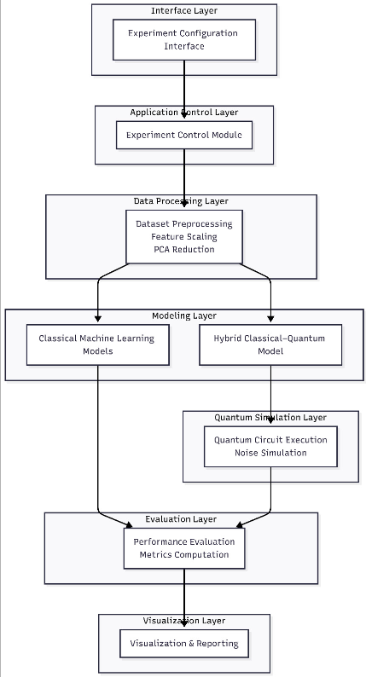

Figure 4.1. High-Level System Architecture of the pipeline and module interaction

C. Hybrid Module
Two hybrid implementations are used in the system. The first combines classical PCA-based dimensionality reduction with VQC classification. The second, a tiny quantum augmentation model, uses a classical backbone (Random Forest or Logistic Regression) to produce probability-based signals, then applies a compact 2-qubit quantum refinement stage. Final predictions are computed through weighted blending of classical and quantum outputs. This dual-hybrid setup allows evaluation of both direct quantum integration and practical classical-first refinement strategies.
D. Reproducibility and Fairness
To ensure fair benchmarking, all model families are evaluated under identical train-test splits, consistent preprocessing conditions, and shared metric computation rules. Repeated experimental runs with fixed random seeds are used to reduce variance from stochastic factors. As a result, observed performance differences can be attributed to model behavior rather than differences in data handling or evaluation methodology.

V. RESULTS AND DISCUSSION

Aggregate outcome
Empirically, classical methods remain the most reliable on this task. Table I summarizes core metrics (mean ± std). The Hybrid model attains the highest mean accuracy (0.839 ± 0.025) and the highest mean recall (0.958), while Random Forest shows higher per-run maxima but larger variability (std ≈ 0.124). Pure VQCs perform substantially worse on average and show greater instability under noise.

Model | Runs | Accuracy | Precision | Recall | F1
Hybrid [RF] (w=0.2) | 6 | 0.839 ± 0.025 | 0.846 | 0.958 | 0.891
Random Forest (PCA-2) | 6 | 0.828 ± 0.124 | 0.842 | 0.955 | 0.889
SVM (PCA-2) | 6 | 0.800 ± 0.070 | 0.781 | 1.000 | 0.876
Logistic Regression (PCA-3) | 6 | 0.761 ± 0.172 | 0.834 | 0.860 | 0.827
VQC ideal (q=2, reps=1) | 6 | 0.611 ± 0.199 | 0.720 | 0.735 | 0.718
VQC noisy (q=2, reps=1) | 12 | 0.586 ± 0.196 | 0.721 | 0.691 | 0.695

Table 1: Core Metrics observed

Hybrid competitiveness
The Hybrid architecture (Random Forest backbone plus a 2-qubit variational refinement) yields consistent sensitivity gains important for screening tasks; Table I reports the Hybrid’s superior recall and F1 relative to pure VQC variants, and Fig. 5.2 confirms reduced variability.

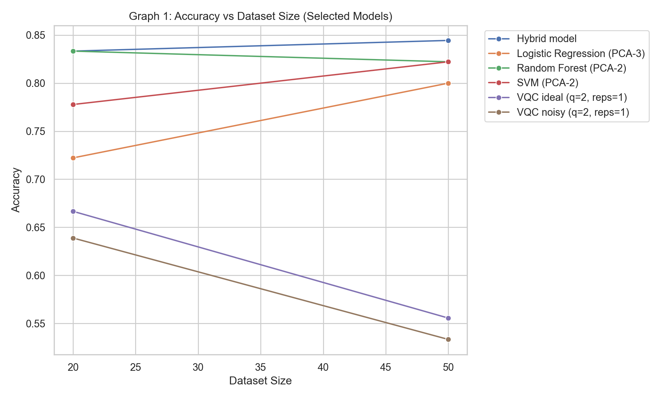
Fig. 5.1 Accuracy by training size

Noise Sensitivity
Noise has a material impact on VQC behavior; Fig. 5.3 compares ideal and depolarizing-noise simulations and shows reductions in ROC shape, mean accuracy, and calibration under noise, with increased inter-run variance.
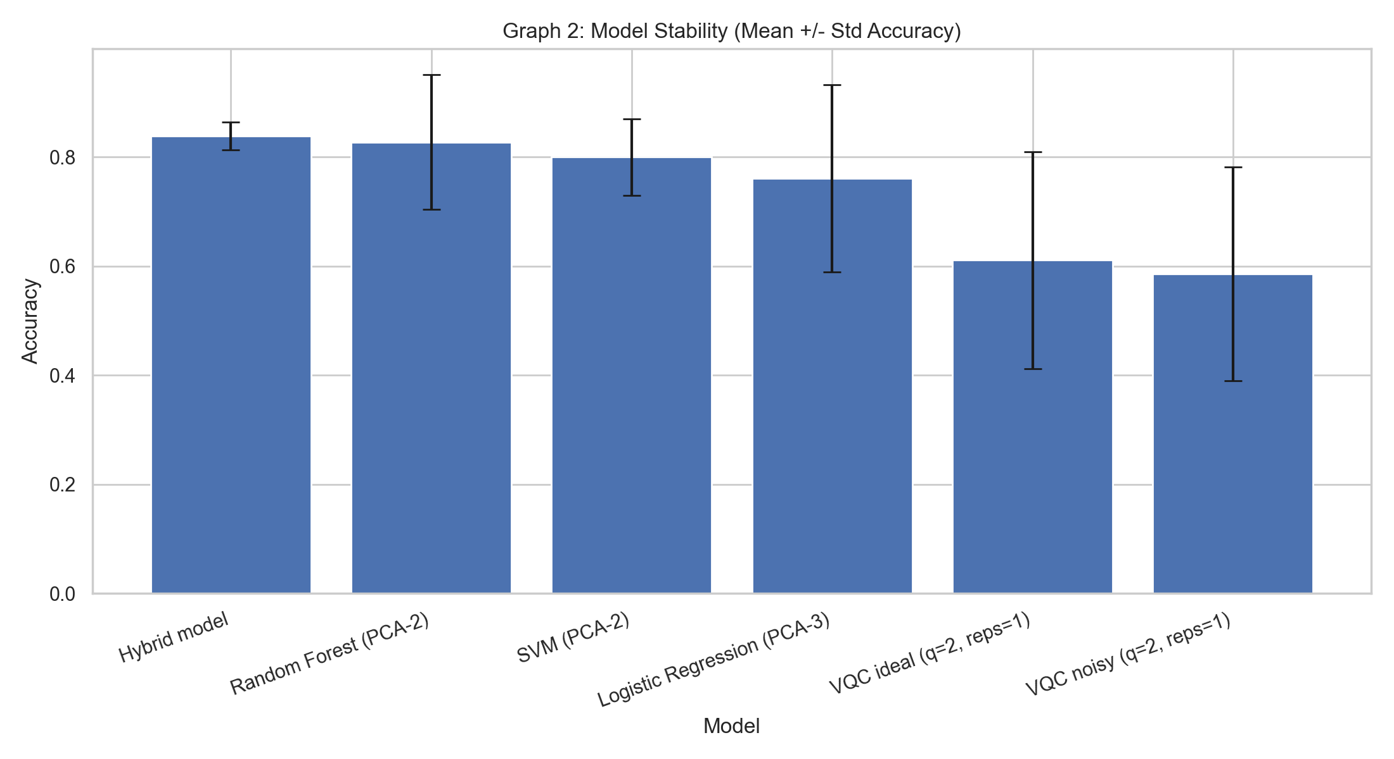
Fig. 5.2 Run-to-run stability

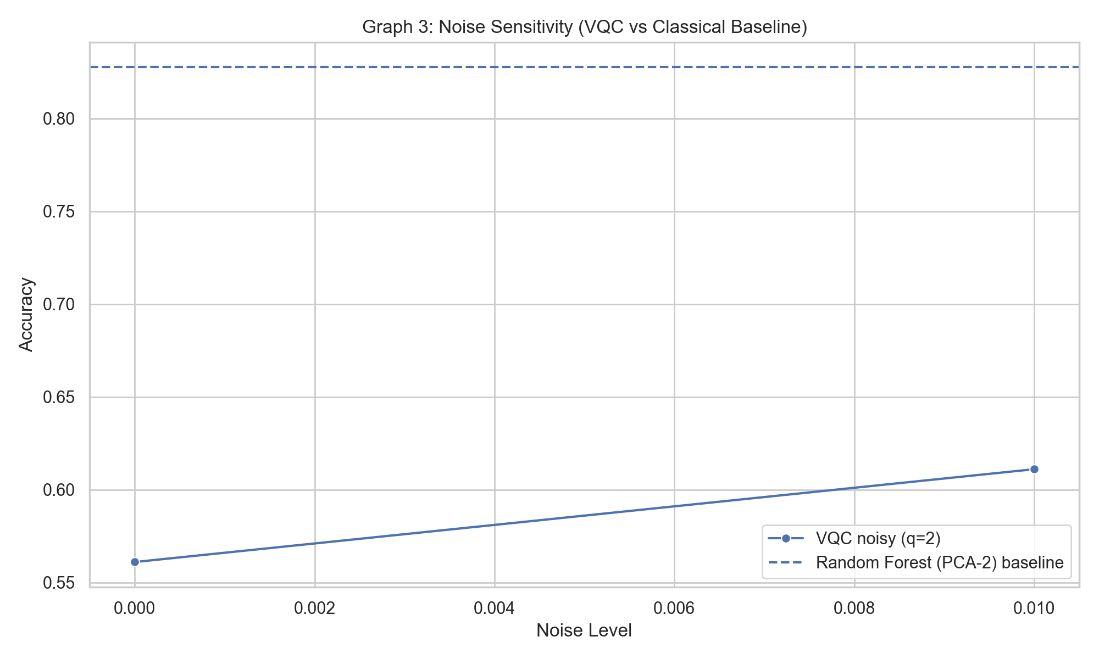
Fig. 5.3 Ideal vs noisy VQC performance

Overfitting and generalization
Train–test analyses (see Appendix) show overfitting for high-capacity families and parameterized VQCs in small-sample regimes. The Hybrid reduces instability relative to pure VQC but does not uniformly outperform the strongest classical baseline on every metric.

Clinical interpretation & runtime
For Parkinson’s screening high recall reduces missed positives. The Hybrid’s higher recall is therefore the primary practical achievement, while runtime costs for quantum simulation and hybrid training remain higher than classical training.

VI. CHALLENGES AND SOLUTIONS
A critical challenge in quantum machine learning is noise sensitivity: NISQ-era devices suffer depolarizing errors and gate infidelities, yet most studies report noiseless results, creating a gap between simulation and hardware performance. We address this by conducting noise-aware experiments with a depolarizing noise model (error probability 0.01 per gate) applied via AerSimulator. Results are reported side-by-side for ideal and noisy circuits (Table I, Fig. 2), quantifying realistic degradation and providing honest benchmarks. Additionally, small-sample instability (n = 20, 50) requires uncertainty quantification. We report all metrics as mean ± std over multiple runs (n = 3–6) and compute train–test gaps (Appendix Fig. A1), enabling confidence assessment.
Pure variational quantum classifiers underperform (≈0.74 accuracy, Table I), lacking practical justification. We adopt a hybrid architecture: a classical backbone (Random Forest, 200 trees) generates probabilities and uncertainty, encoded as quantum features [p, entropy], refined by a 2-qubit VQC with quantum weight w = 0.2. This yields 0.839 mean accuracy, validating the refinement approach. For fair comparison, we enforce unified preprocessing (standardization + PCA), fixed train–test splits, common metrics (accuracy, precision, recall, F1, ROC-AUC, generalization gap), and consistent hyperparameters (Random Forest 200 trees, VQC 80 iterations, PCA 2–3 components), ensuring reported differences reflect genuine model distinctions.

VII. CONCLUSION AND FUTURE WORK
This empirical study demonstrates that a simple hybrid quantum-classical architecture can provide practical refinements to classical machine learning in small-sample biomedical classification tasks. The Hybrid model achieved the best mean accuracy (0.839 ± 0.025) and highest recall (0.958), outperforming pure VQCs and maintaining competitive performance with classical baselines while delivering sensitivity gains valuable for screening. Crucially, our noise-aware evaluation reveals that realistic depolarizing noise significantly degrades pure VQC performance, highlighting the necessity of realistic benchmarking and the appeal of hybrid architectures that are less sensitive to quantum fragility.
Key limitations include small training set sizes (n = 20, 50) and reliance on simulation (AerSimulator) rather than hardware. Future work should: (i) expand to larger datasets and prospective cohorts for clinical validation; (ii) run experiments on actual quantum hardware to test noise models and assess scalability; (iii) explore deeper VQC architectures and alternative ansatze; (iv) apply the Hybrid framework to other biomedical domains (cancer detection, cardiac risk); and (v) develop theoretical bounds on quantum refinement gains. The present results establish a baseline for quantum-classical integration and underscore the importance of noise-aware, metric-focused evaluation when comparing quantum and classical approaches on realistic tasks.

Acknowledgment
The authors would like to thank the Department of Computer Science and Engineering, MSRIT, for providing the necessary resources and institutional support throughout the course of this project. Special thanks are extended to our peers and the institutional IT support team for their valuable assistance during the development, deployment, and testing phases of the system.

References
- M. A. Little, P. E. McSharry, E. J. Hunter, J. Spielman, and L. O. Ramig, “Suitability of dysphonia measurements for telemonitoring of Parkinson’s disease,” Biomed. Eng. Online, vol. 6, p. 23, 2007, doi:10.1186/1475-925X-6-23.
- A. Tsanas, M. A. Little, P. E. McSharry, and L. O. Ramig, “Accurate telemonitoring of Parkinson’s disease progression by noninvasive speech tests,” IEEE Trans. Biomed. Eng., vol. 57, no. 4, pp. 884–893, Apr. 2010, doi:10.1109/TBME.2009.2039213.
- V. Havlíček, A. D. Córcoles, K. Temme, A. W. Harrow, A. Kandala, J. M. Chow, and J. M. Gambetta, “Supervised learning with quantum-enhanced feature spaces,” Nature, vol. 567, pp. 209–212, 2019, doi:10.1038/s41586-019-0980-2.
- M. Schuld and N. Killoran, “Quantum machine learning in feature Hilbert spaces,” Phys. Rev. Lett., vol. 122, p. 040504, Jan. 2019, doi:10.1103/PhysRevLett.122.040504.
- M. Cerezo, A. Sone, T. Volkoff, L. Cincio, and P. J. Coles, “Variational quantum algorithms,” Nat. Rev. Phys., vol. 3, pp. 625–644, 2021, doi:10.1038/s42254-021-00348-9.
- K. Bharti et al., “Noisy intermediate-scale quantum algorithms,” Rev. Mod. Phys., vol. 94, p. 015004, 2022, doi:10.1103/RevModPhys.94.015004.
- A. Abbas et al., “The power of quantum neural networks,” Nat. Comput. Sci., 2021. (Publisher DOI / pages available at publisher site.)
- IBM Quantum, “Qiskit Documentation,” https://qiskit.org/documentation/ (accessed May 6, 2026).
- F. Pedregosa et al., “Scikit-learn: Machine Learning in Python,” J. Mach. Learn. Res., vol. 12, pp. 2825–2830, 2011. [Online]. Available: https://jmlr.org/papers/v12/pedregosa11a.html
- UCI Machine Learning Repository, “Parkinsons Data Set,” https://archive.ics.uci.edu/ml/datasets/parkinsons (accessed May 6, 2026).
- L. Breiman, “Random forests,” Mach. Learn., vol. 45, no. 1, pp. 5–32, 2001, doi:10.1023/A:1010933404324.
- C. Cortes and V. Vapnik, “Support-vector networks,” Mach. Learn., vol. 20, no. 3, pp. 273–297, 1995, doi:10.1007/BF0099401

